MARKING GUIDELINE

NATIONAL CERTIFICATE (VOCATIONAL)

LIFE SKILLS AND COMPUTER LITERACY

(ICT COMPONENT)

(Second paper)

NQF LEVEL 2

26–28 October 2022

This marking guideline consists of 14 pages.

INSTRUCTIONS TO MARKERS

To facilitate marking and moderation, the following must be adhered to:

1. | Markers are required to work out the question paper before the marking guideline discussion.

2. | Accuracy is marked negatively with a red pen (/). Manipulation is marked with a blue pen (X or) and the manipulation number must be written next to every tick () or cross (X) e.g. 1/1X.
 | If 3 marks are allocated for accuracy but a candidate made 5 errors, he/she only loses a maximum of 3 marks for accuracy and is still rewarded for the manipulation that was done correctly.
3. | To aid with the marking process it is suggested that a transparency template is made of the breakdown of the marks at the beginning of the marking guideline discussion for each question. All marking on the PRINTOUT (ticks and crosses) must be made in the same position as indicated on the marking guideline template.

4. | Accuracy errors include spelling errors/ keying-in errors, omissions and repetitions. Uppercase, lower case and letter spacing are marked as manipulation errors.

5. | All irregularities are marked and marks are transferred to the COVER PAGE. The code 'IRR' or word 'IRREGULARITY' is written next to the percentage and an irregularity report is completed.

6. | The following table format can be used to the write marks achieved for each question on the PRINTOUT (NB: numbers in the table are for demonstration purposes only):
   | A | M | T
  Write the total possible mark in this line | 9 | 12 | 21
  Write the errors made by the candidate in this line | 1 | 2 | 3
  Write the marks achieved by the candidate in this line | 8 | 10 | 18

7. | The candidate's total mark is written on the COVER PAGE of the EXAMINATION FOLDER next to the corresponding QUESTION NUMBER.

8. | If the candidate handed in a PRINTOUT, but achieved 0 (zero) for the question, then 0 (zero) is written on the cover page next to the corresponding QUESTION NUMBER.

9. | If a candidate did not hand in a PRINTOUT, a line is drawn across the block next to the corresponding QUESTION NUMBER.

10. | All PRINTOUTS must include the candidate's printed EXAMINATION NUMBER and a CONSISTENT WATERMARK. If a candidate handed in a PRINTOUT without a printed EXAMINATION NUMBER and a CONSISTENT WATERMARK, the question must be marked and reported as an irregularity.

11. | ONLY mark according to the MARKING GUIDELINE indicates and do not penalise candidates for automatic formats or styles used, for example in MS Office 2007.

SECTION A: WORD PROCESSING

QUESTION 1

MARK ALLOCATION

ACCURACY | 7
MANIPULATION | 13
TOTAL | 20

QUESTION  NUMBER | MARKS | ACCURACY
1.1 |  | Penalise all typing errors such as spelling, omission and repetition of text. Deduct ONE mark per error in the document up to a maximum of SEVEN marks.  REMEMBER: Do not penalise errors twice, rather encircle them. Also, do not penalise letter spacing, upper case and lower case under accuracy.

QUESTION NUMBER | NUMBERING | MARK | MANIPULATION
1.2 | 1 |  | Header inserted
1.2 | 2 |  | EXAMINATION NUMBER and  QUESTION 1: centre-aligned
1.2 | 3 |  | Layout: QUESTION 1 typed below EXAMINATION NUMBER
1.3 | 4 |  | Font type: Century Gothic consistent throughout the entire document
1.3 | 5 |  | Font size: 12
1.4 | 6 |  | Main heading: centred-aligned
1.4 | 7 |  | Main heading: underlined
1.5 | 8 |  | 'Universal Declaration of Human Rights': in italics
1.6 | 9 |  | Line spacing: consistent throughout the document
1.7 | 10 |  | Numbered list inserted
1.1 | 11 |  | Upper case, lower case and letter spacing: consistent throughout the entire document
1.9 | 12 |  | Printed: ONE A4 page
1.9 | 13 |  | Page orientation: portrait

EXAMINATION NUMBER
QUESTION 1

4. Font type: Century Gothic
5. Font Size: 12
6. Main heading: centre-aligned
7. Main heading: underlined

The Constitution of South Africa

The Constitution is the supreme law of the country. All our rights are outlined in Chapter 2, the Bill of Rights (BoR).

The Bill of Rights provides over 25 basic rights and freedoms to all people in South Africa and it is based on the Universal Declaration of Human Rights.
8. Italics

Human rights are the basic rights which the government must protect. These rights are covered by the Constitution to protect us. In an instance where one's right is violated, one can open a court case. As it is very difficult to change the Constitution, it is also very difficult for anyone to take away one’s your human rights!

However, remember that human rights can sometimes be limited. This means that they could be changed, restricted, or even taken away. This can only be done if:

1. | The law which limits a right applies to everybody
2. | There is a good reason to limit the right
3. | To limit the right makes sense in an open and democratic country
9. Line spacing consistent

10. Numbered list correctly inserted

HEADER:
1. Examination number & Question 1 inserted
2. Examination number & Question number: centre-aligned
3. Layout: Question 1 typed below Examination number

13. Page orientation: portrait page

11. Upper case, lower case and letter spacing consistent
12. Printed on ONE A4 page

A | M | T
7 | 13 | 20

[20]

QUESTION 2

MARK ALLOCATION

ACCURACY | 4
MANIPULATION | 16
TOTAL | 20

QUESTION  NUMBER | MARKS | ACCURACY
2.1 |  | Penalise all typing errors such as spelling, omission and repetition of text. Deduct ONE mark per error in the document up to a maximum of FOUR marks.  REMEMBER: Do not penalise errors twice, rather encircle them. Also, do not penalise letter spacing, upper case and lower case under accuracy.

QUESTION NUMBER | NUMBERING | MARK | MANIPULATION
2.2 | 1 |  | Question number: changed to QUESTION 2
2.3 | 2 |  | Main heading: font type: Comic Sans MS
2.3 | 3 |  | Main heading: font size 18
2.3 | 4 |  | Main heading: bold
2.3 | 5 |  | Main heading: upper case
2.4 | 6 |  | Deleted paragraph ('Human rights are the basic rights … human rights!')
2.5 | 7 |  | Paragraph 3 right- aligned ('However, remember that human rights can … done if:')
2.6 | 8 |  | Double underline 'The RIGHTS in the Bill of Rights'
2.7 | 9 |  | Font type: ALGERIAN ('The RIGHTS in the Bill of Rights')
2.7 | 10 |  | Font size: 14 ('The RIGHTS in the Bill of Rights')
2.8 | 11 |  | Numbers replaced with the same bullets of the newly inserted text.
2.9 | 12 |  | Newly inserted text: bold
2.1 | 13 |  | Upper case/lower case consistent: newly inserted text only.
2.1 | 14 |  | Line spacing/letter spacing consistent: newly inserted text only.
2.11 | 15 |  | Printed: ONE A4 page
2.11 | 16 |  | Page orientation: portrait

EXAMINATION NUMBER
QUESTION 2
Main Heading : 2. Font type: Comic Sans MS 3. Font size: 18 4. Bold 5. Upper case

THE CONSTITUTION OF SOUTH AFRICA

The Constitution is the supreme law of the country. All our rights are outlined in Chapter 2, the Bill of Rights (BoR).

The Bill of Rights provides over 25 basic rights and freedoms to all people in South Africa and it is based on the Universal Declaration of Human Rights.
6. Paragraph deleted

However, remember that human rights can sometimes be limited. This means that they could be changed, restricted, or even taken away. But this can only be done if:
7. Paragraph right-aligned

The law which limits a right applies to everybody
There is a good reason to limit the right
To limit the right makes sense in an open and democratic country
Heading : 8. Double underline 9. Font type: ALGERIAN 10. Font Size: 14

The RIGHTS in the Bill of Rights

People have the right to be treated equally and with dignity
To live in freedom and security
To live in a healthy environment
To exercise freedom of association and movement
The right to vote
12. Newly inserted text: bold

11. Numbering replaced with bullets

13. Upper case/lower case: newly inserted text only

- Question 1 changed to Question 2

A | M | T
4 | 16 | 20
14. Line/letter spacing: newly inserted text only

15. Printed on ONE A4 page

16. Page orientation: portrait

[20]

SECTION B: SPREADSHEET

QUESTION 3

MARK ALLOCATION

ACCURACY | 4
MANIPULATION | 11
TOTAL | 15

QUESTION  NUMBER | MARKS | ACCURACY
3.1 |  | Penalise all typing errors such as spelling, omission and repetition of text. Deduct one mark per error in the document up to a maximum of FOUR marks.  REMEMBER: Do not penalise errors twice, rather encircle them. Also, do not penalise letter spacing, upper case and lower case under accuracy.

QUESTION NUMBER | NUMBERING | MARK | MANIPULATION
3.2 | 1 |  | Header inserted
3.2 | 2 |  | EXAMINATION NUMBER: left-aligned
3.2 | 3 |  | QUESTION 3: right-aligned
3.3 | 4 |  | Font type: Bookman Old Style (used for entire document)
3.3 | 5 |  | Font size: 10
3.4 | 6 |  | Left ONE open row
3.5 | 7 |  | Column width adjusted to ensure all information is clearly visible.
3.1 | 8 |  | Upper case/lower case consistent throughout document
3.7 | 9 |  | Printed: ONE A4 page  NB. : The mark for portrait orientation is awarded below – No 11
3.7 | 10 |  | Printed: without row and column headings
3.5 | 11 |  | Page orientation: portrait

1. Header inserted
2. EXAMINATION NO L/A

3. QUESTION 3 R/A

QUESTION 3
EXAMINATION NUMBER

 | A | B | C | D | E
1 | SOUP PROJECT
2
3 | Product | Quantity | Unit Price
4 | Soup ingredients
5 | Green beans (600g) | 4 | 29,99
6 | Potatoes (10kg) | 2 | 69,99
7 | Carrots (5kg) | 1 | 29,99
8 | Celery (bunches) | 4 | 25
9 | Chicken broth (450ml) | 30 | 39
10 | Onions (3kg) | 4 | 36,99
11 | Green Peppers | 3 | 50
12 | Bread (loaves) | 20 | 14,5
13 | Margarine (tubs) | 4 | 25,99
14

6. ONE row left open
7. Column widths adjusted – all information visible
8. Uppercase/Lowercase throughout document
9. Printed on ONE A4 page
10. Printed without row & column headings
11. Page Orientation : portrait

A | M | T
4 | 11 | 15

[15]

QUESTION 4

MARK ALLOCATION

ACCURACY | 2
MANIPULATION | 23
TOTAL | 25

MARKS | ACCURACY
Mark only the newly inserted text (all keying-in errors, spelling, omissions and repetitions). Deduct ONE mark per error in the document up to a maximum of 2 marks.
(Do not penalise errors from the previous question)

QUESTION NUMBER | NUMBERING | MARK | MANIPULATION
4.1 | 1 |  | Change the question number to QUESTION 4
4.2 | 2 |  | Main heading: font type: Colonna MT
4.2 | 3 |  | Main heading: font size: 24
4.3 | 4 |  | Main heading: merged and centre-aligned across cells A1 to D1.
4.4 | 5 |  | Subheading inserted (NUMBER OF CHILDREN) with corresponding value (200)
4.4 | 6 |  | Sub heading: 'NUMBER OF CHILDREN' underlined
4.5 | 7 |  | New column correctly inserted (Cost Price)
4.6 | 8 |  | Column headings: bold
4.6 | 9 |  | Column headings: upper case
4.7 | 10 |  | Row 13 deleted (Green Peppers)
4.8 | 11 |  | Insert new rows
4.8 | 12 |  | TOTAL UNIT PRICE, TOTAL COST PRICE COST PER CHILD and ESTIMATED PROFIT: right-aligned
4.9 | 13 |  | A = COST PRICE correctly calculated
4.9 | 14 |  | B = TOTAL COST PRICE correctly calculated
4.9 | 15 |  | C = COST PER CHILD correctly calculated
4.9 | 16 |  | D = TOTAL UNIT PRICE correctly calculated
4.9 | 17 |  | E = ESTIMATED PROFIT correctly calculated
4.10 | 18 |  | UNIT PRICE, COST PRICE, TOTAL COST PRICE, TOTAL UNIT PRICE, COST PER CHILD and ESTIMATED PROFIT: Displayed as currency with TWO decimals.

4.11 | 19 |  | Horizontal and vertical lines correctly inserted.
4.12 | 20 |  | Column width correctly adjusted and all information is clearly visible.
4.14 | 21 |  | Printed on ONE A4 page
4.14 | 22 |  | Page orientation: landscape
4.14 | 23 |  | Printed without rows and column headings

- Question number changed to QUESTION 4

QUESTION 4
EXAMINATION NUMBER
 | A | B | C | D | E
1 | SOUP PROJECT
2
3 | NUMBER OF CHILDREN | 200
4
5 | PRODUCT | QUANTITY | UNIT PRICE | COST PRICE
6 | Soup ingredients
7 | Green beans (600g) | 4 | R29,99 | R119,96
8 | Potatoes (10kg) | 2 | R 69,99 | R 139,98
9 | Carrots (5kg) | 1 | R 29,99 | R29,99
10 | Celery (bunches) | 4 | R 25,00 | R 100,00
11 | Chicken broth (450ml) | 30 | R 39,00 | R1 170,00
12 | Onions (3kg) | 4 | R 36,99 | R 147,96
13 | Bread (loaves) | 20 | R 14,50 | R290,00
14 | Margarine (tubs) | 4 | R 25,99 | R 103,96
15 | TOTAL UNIT PRICE |  | R 271,45
16 | TOTAL COST PRICE |  |  | R2 101,85
17 | COST PER CHILD |  |  | R10,51
18 | ESTIMATED PROFIT |  |  | R 1830,40
A | M | T
2 | 23 | 25
Sub-heading :
- Inserted with corresponding value
- Underlined
- Merged & centred across A1- D1

Main Heading :
- Font type : Colonna MT
- Font size: 24
- Merged & centred across A1- D1

- UNIT PRICE, COST PRICE, TOTAL COST PRICE, TOTAL UNIT PRICE, COST PER CHILD and ESTIMATED PROFIT: displayed as currency with 2 decimal places
- Vertical and horizontal lines inserted.
- Column width adjusted
- Printed : ONE A4 page
- Page Orientation: Landscape
- Printed: row and column headings

New Rows :
- A: COST PRICE correctly calculated
- B: TOTAL COST PRICE correctly calculated
- C: COST PER CHILD correctly calculated
- D: TOTAL UNIT PRICE correctly calculated
- E: ESTIMATED PROFIT correctly calculated

New Rows :
- New row inserted
- TOTAL UNIT PRICE, TOTAL COST PRICE, COST PER CHILD and ESTIMATED PROFIT: right-aligned

- Row 13 (Green Peppers) deleted

New column :
- New column inserted
- Heading : Bold
- Heading : Uppercase

[25]

SECTION C: POWERPOINT

QUESTION 5

MARK ALLOCATION

ACCURACY | 4
MANIPULATION | 16
TOTAL | 20

QUESTION  NUMBER | MARKS | ACCURACY
5.1 |  | Penalise ALL typing errors in both slides up to a MAXIMUM of FOUR marks. Do NOT penalise upper case and lower case under ACCURACY.

QUESTION NUMBER | NUMBERING | MARK | MANIPULATION
SLIDE 1: TITLE SLIDE
5.2 | 1 |  | Title slide inserted
5.2.1 | 2 |  | Title: font type: Broadway
5.2.1 | 3 |  | Title: font size: 44
5.2.1 | 4 |  | Title: upper case
5.2.2 | 5 |  | Sub title: text right-aligned
5.2.3 | 6 |  | Footer: QUESTION 5 and EXAMINATION NUMBER inserted & applied to both slides (accept any alignment)
SLIDE 2: COMPARISON SLIDE
5.3 | 7 |  | Comparison slide inserted
5.3.1 | 8 |  | Title: font type: Bradley Hand ITC
5.3.1 | 9 |  | Title: font size: 40
5.3.2 | 10 |  | Correct numbering inserted in the left column
5.3.2 | 11 |  | Left column: text appears in bold
5.3.3 | 12 |  | Correct bullets inserted in the right column
5.3.3 | 13 |  | Right column: text appears in italics
5.3.4 | 14 |  | Column headings: underlined
5.1 | 15 |  | Upper case/lower case consistent throughout
5.5 | 16 |  | Printed: full-page slides (ONE slide per page)

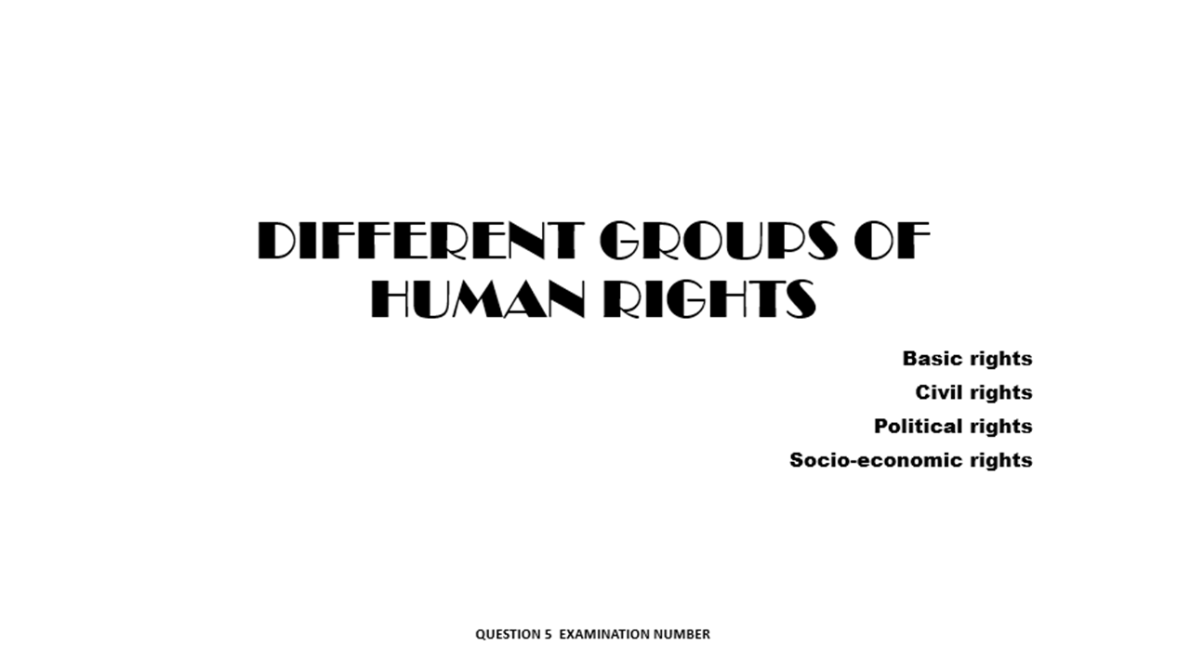
6. Footer: QUESTION 5 and EXAMINATION NUMBER inserted on both slides

5. Text right-aligned

1. Title slide

2. Font type: Broadway 3. Font size 44 4.Upper case

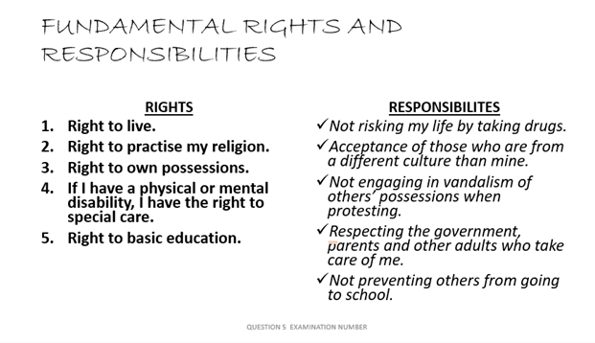
14. Column headings: underlined

12. Right Column: correct bullets
13. Right Column: italics

10. Left Column: correct numbering
11. Left Column: bold

8. Font type: Bradley Hand ITC 9. Size 40

7. Comparison slide

A | M | T
4 | 16 | 20
15. Upper case/lower case consistent
16. Printed: full-page slides (ONE slide per page)

[20]

TOTAL SECTION C: |  | 20
GRAND TOTAL: |  | 100

